**OUTPUT SCREENSHOTS**

1. HOME PAGE:

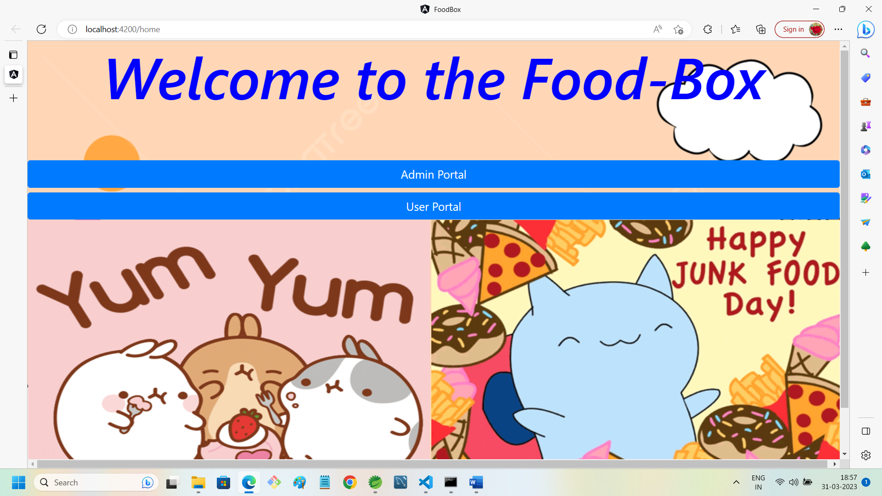

**2. ADMIN PORTAL WITH SLIDE IMAGE1:**

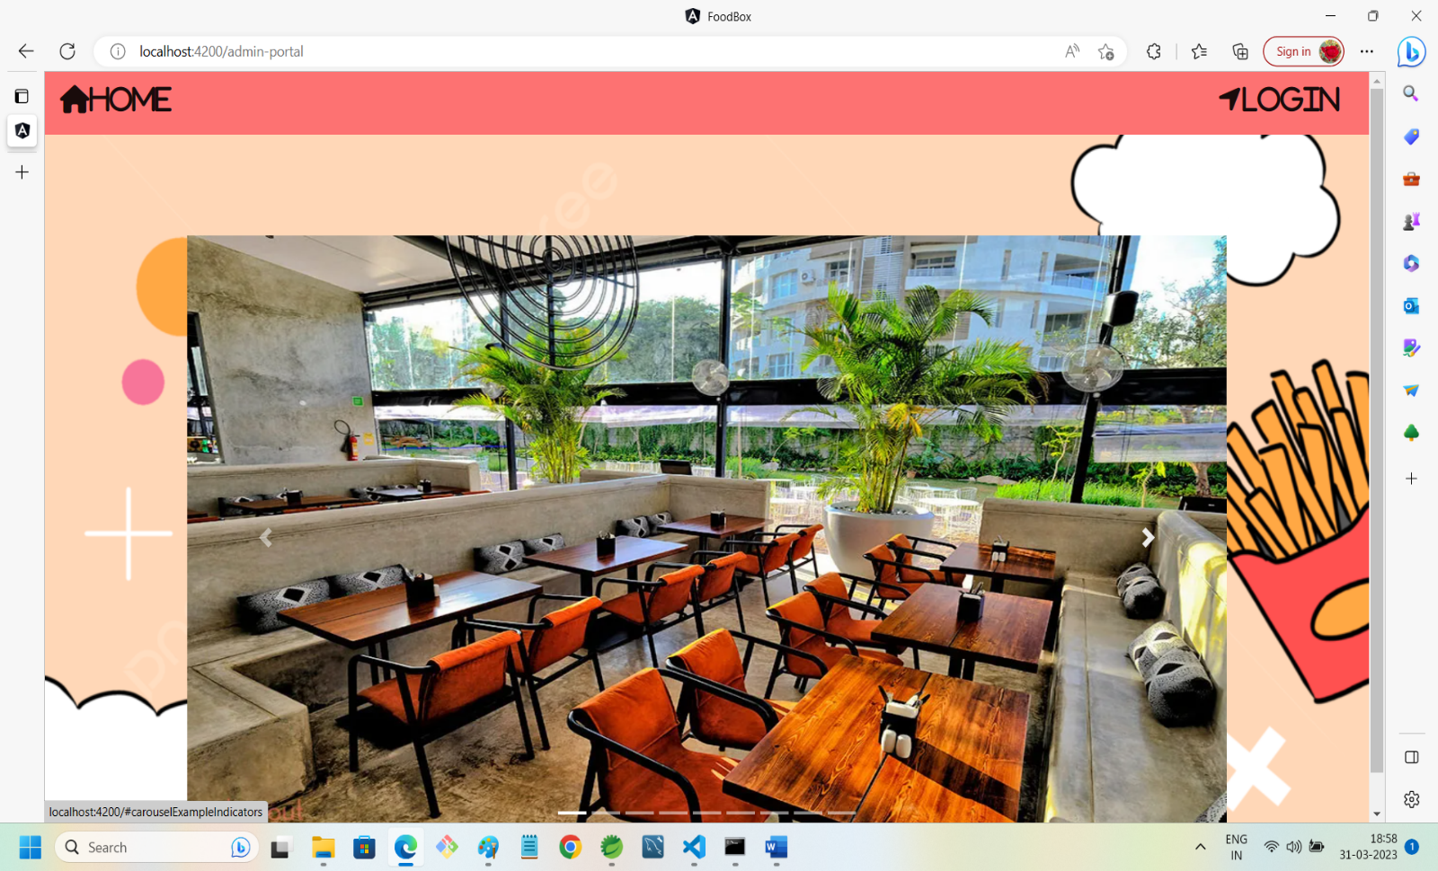

3. **ADMIN PORTAL WITH SLIDE IMAGE2:**

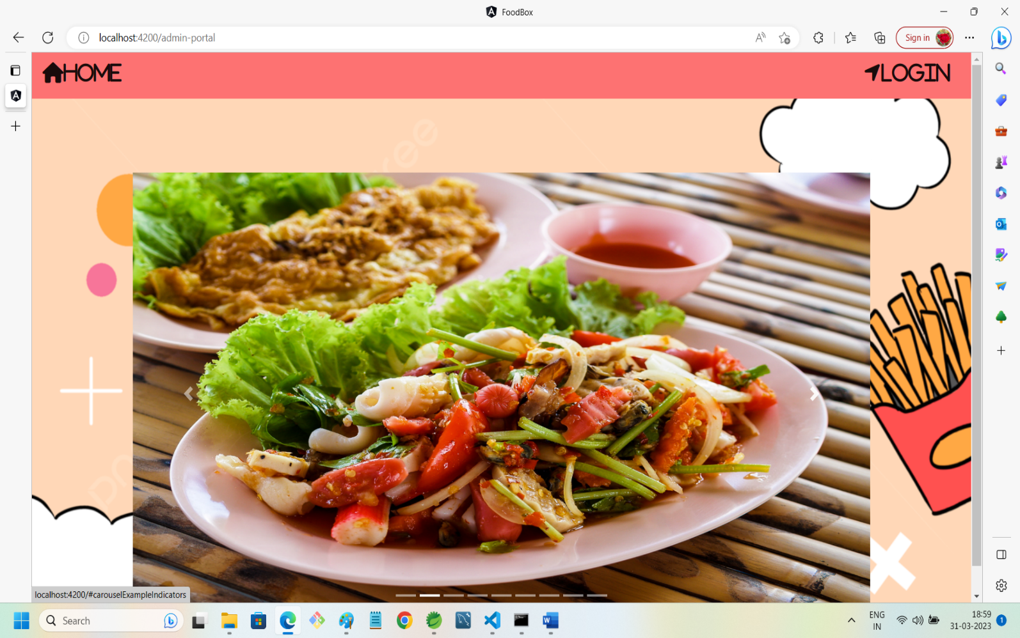

4. **ADMIN PORTAL WITH SLIDE IMAGE3:**

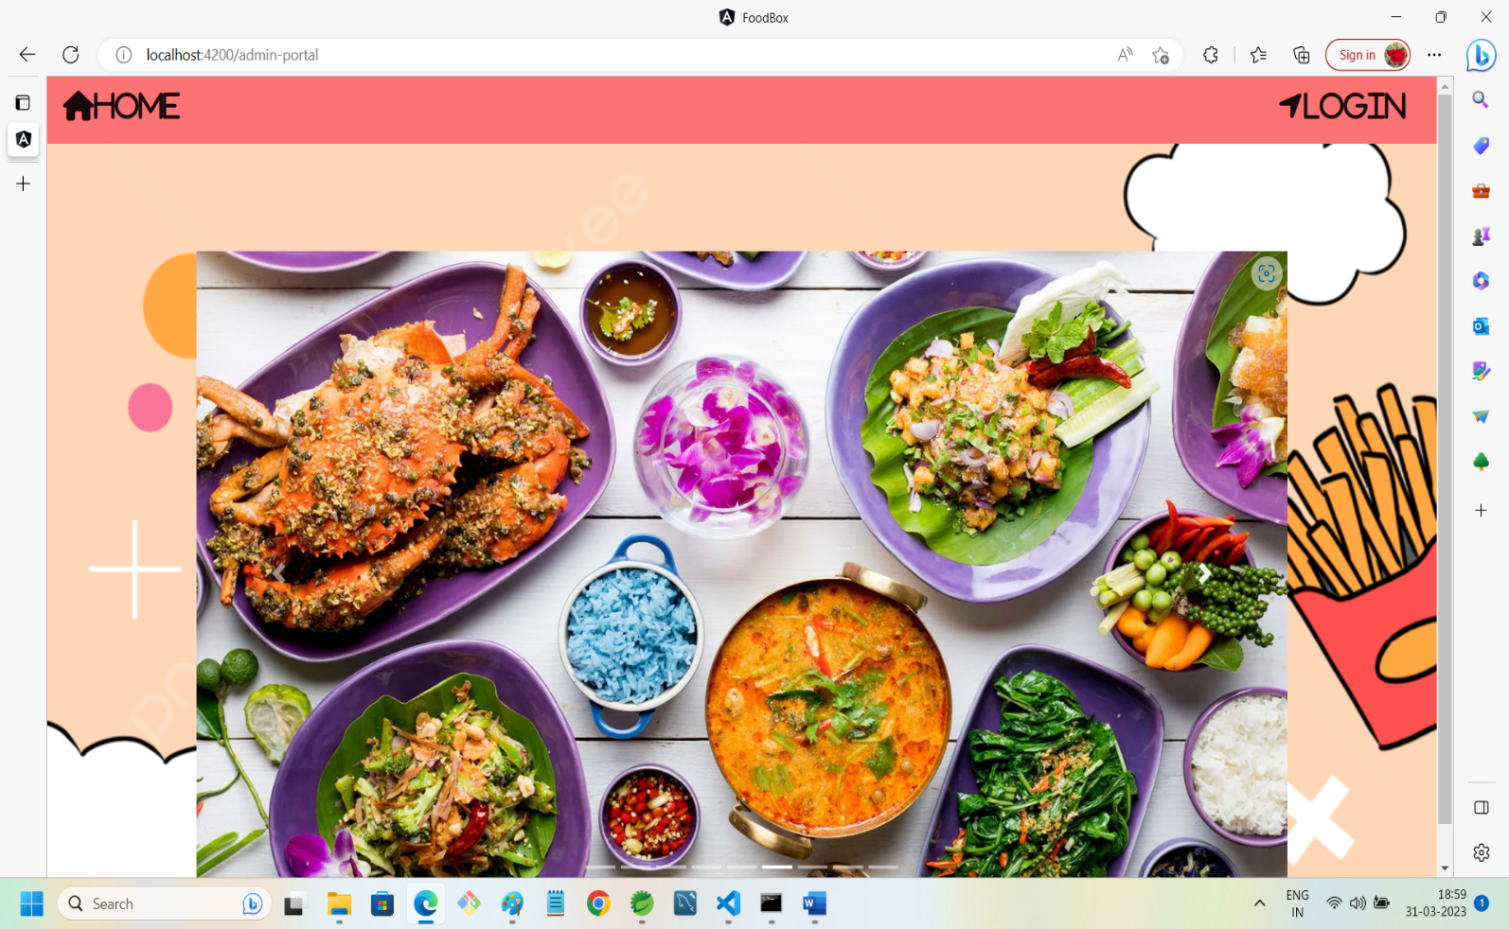

5. ADMIN LOGIN SECTION:

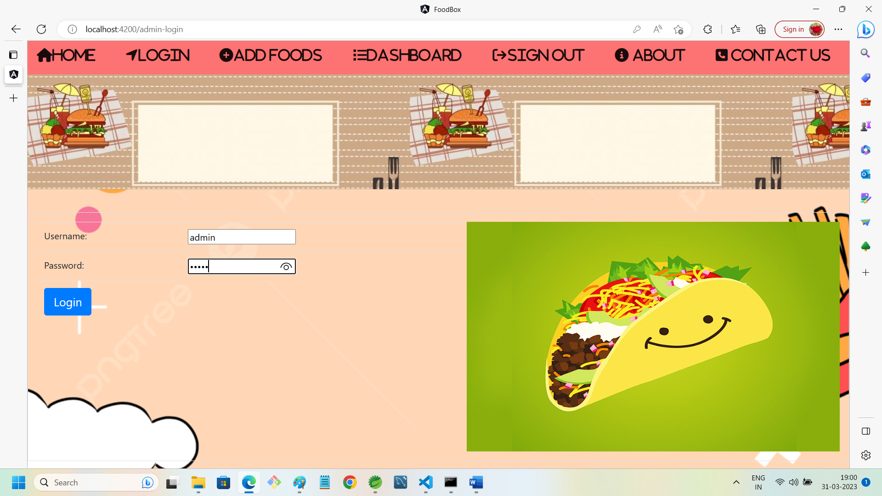

6. ADMIN DASHBOARD AFTER ENTERING VALID CREDENTIALS:

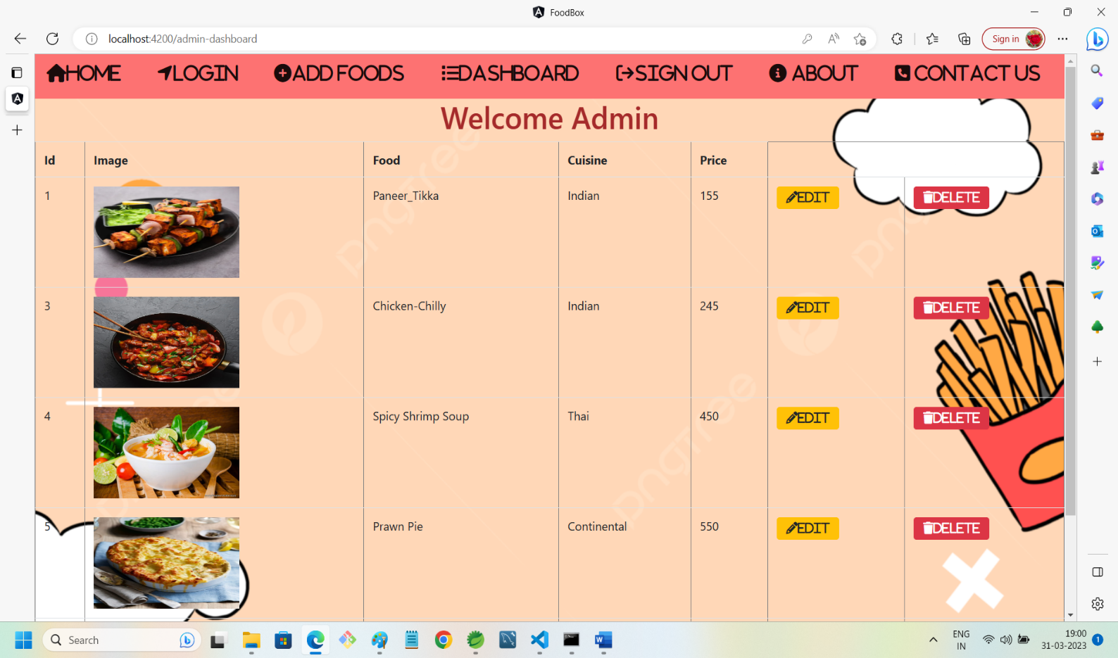

7. ADMIN CAN EDIT FOOD DETAIL:

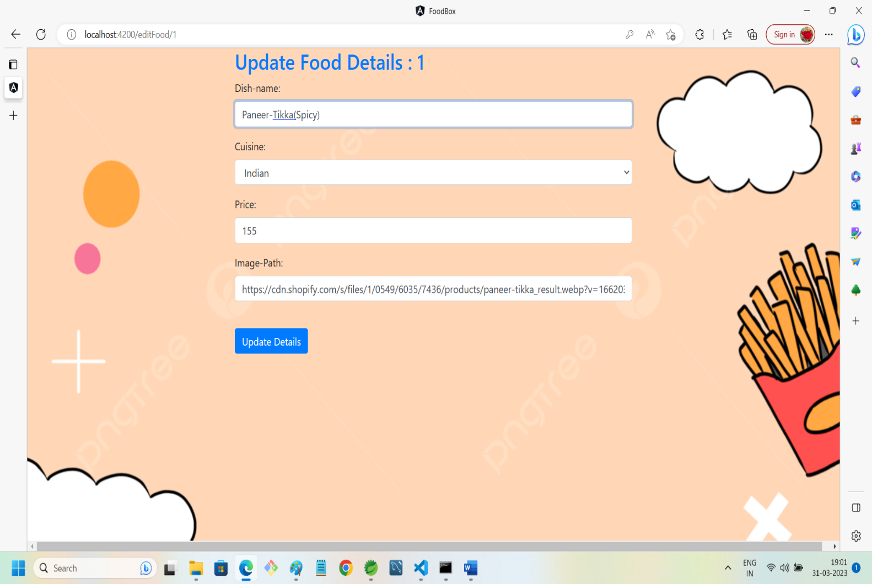

8. DATA UPDATED SUCCESSFULLY:

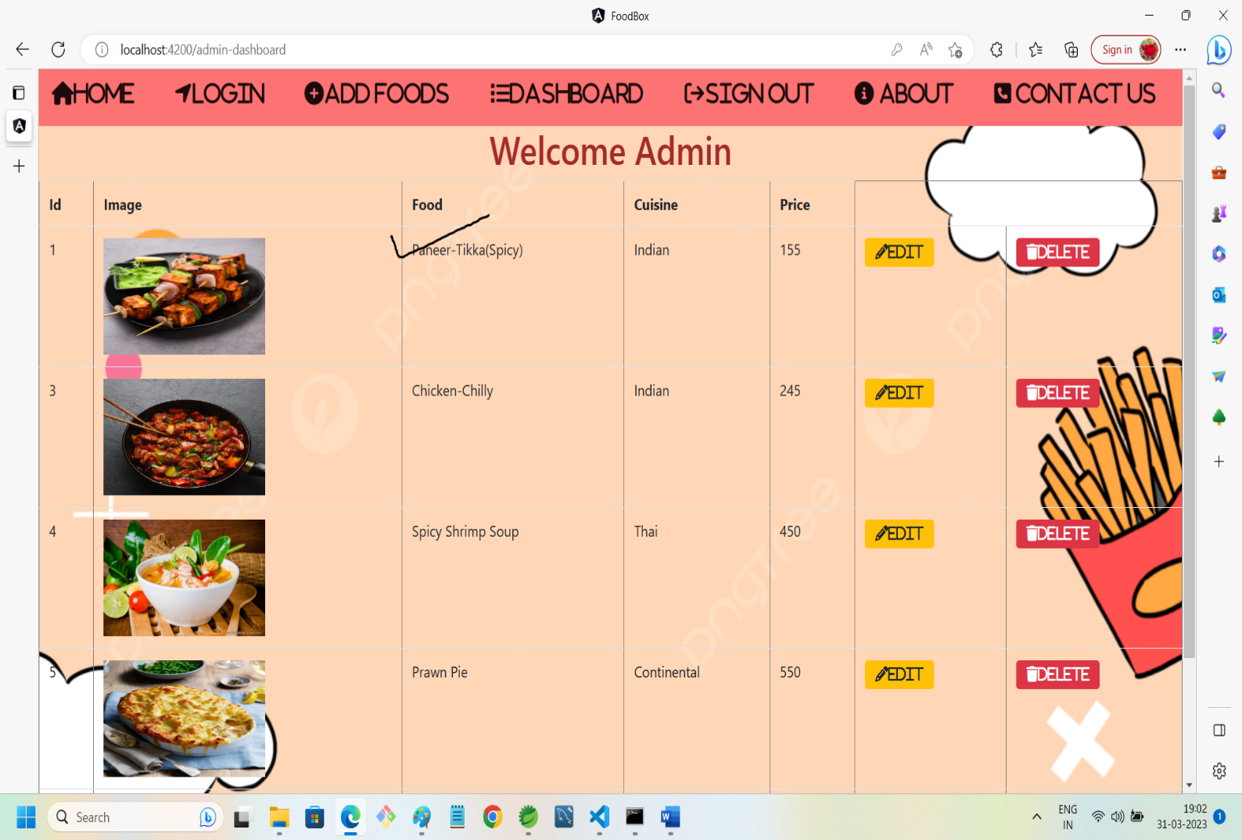

9. ADD FOOD:

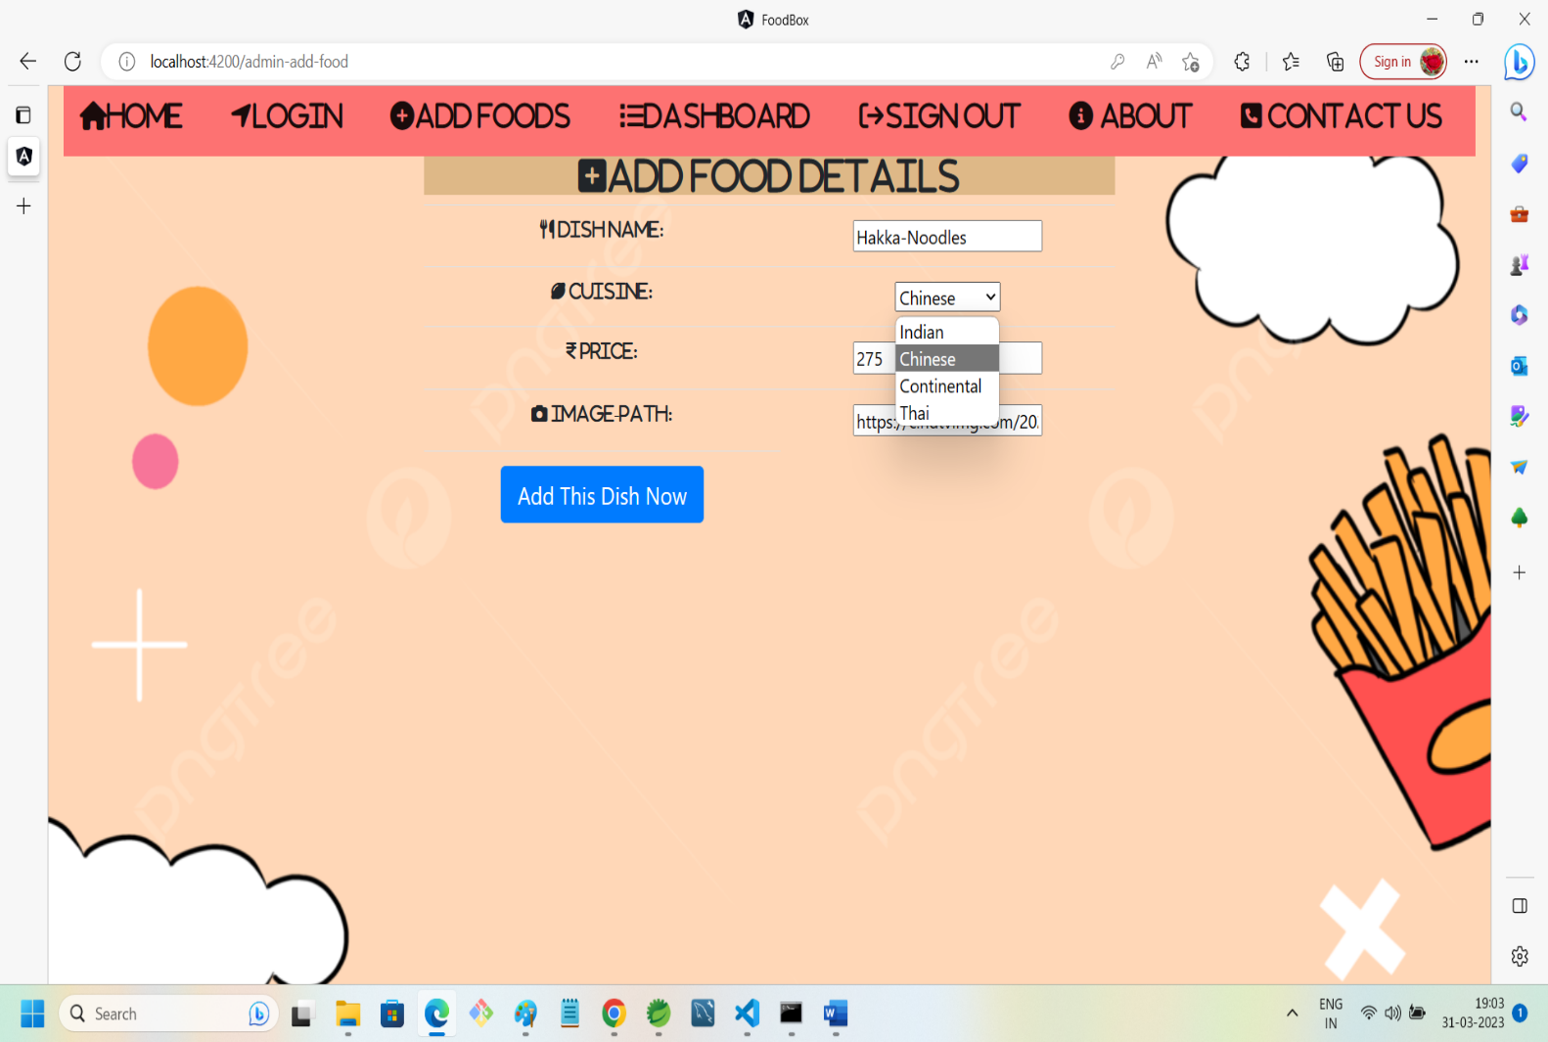

10. DATA ADDED SUCCESSFULLY:

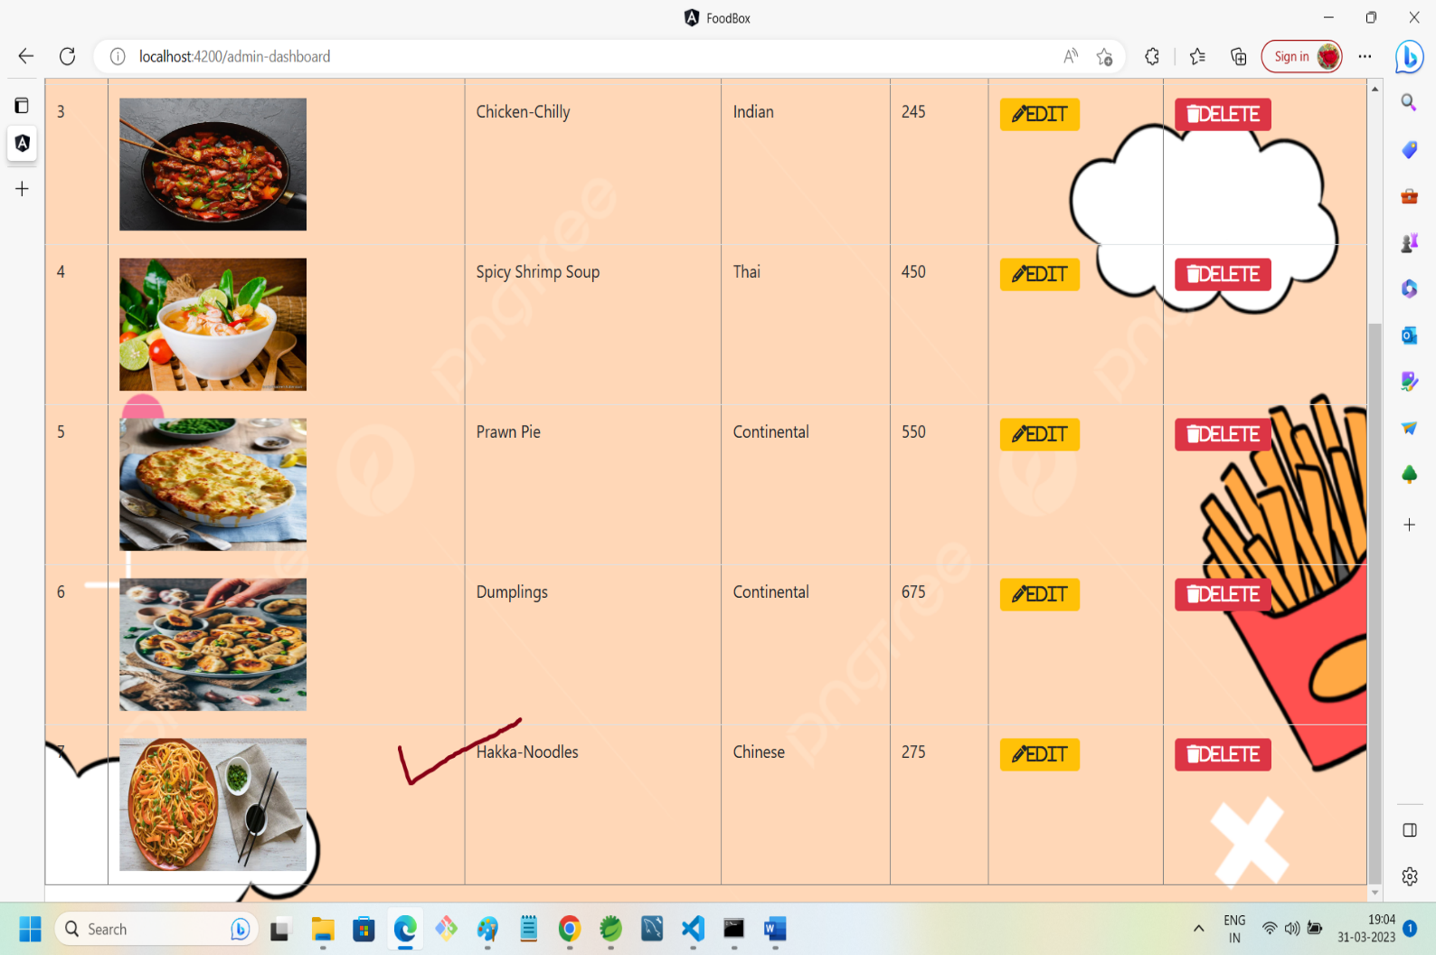

11. ABOUT US SECTION:

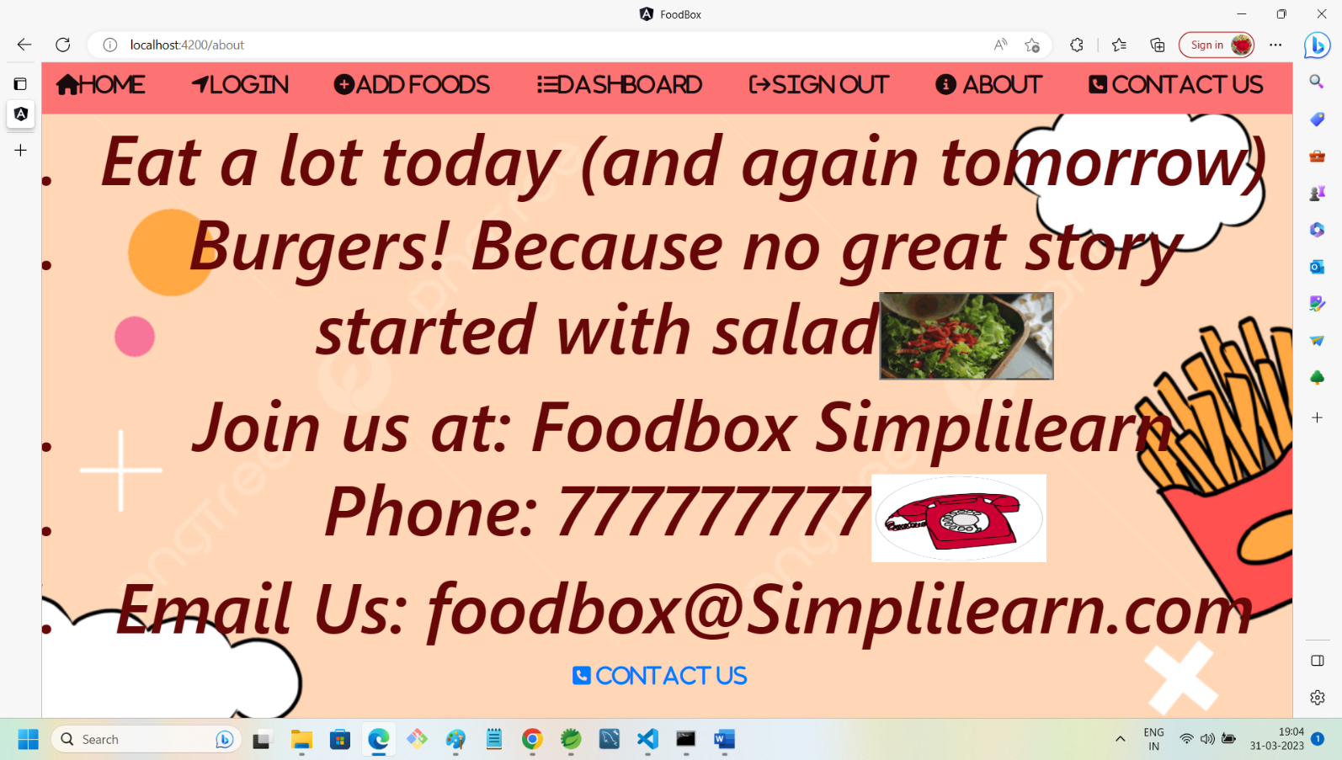

12. CONTACT US SECTION:

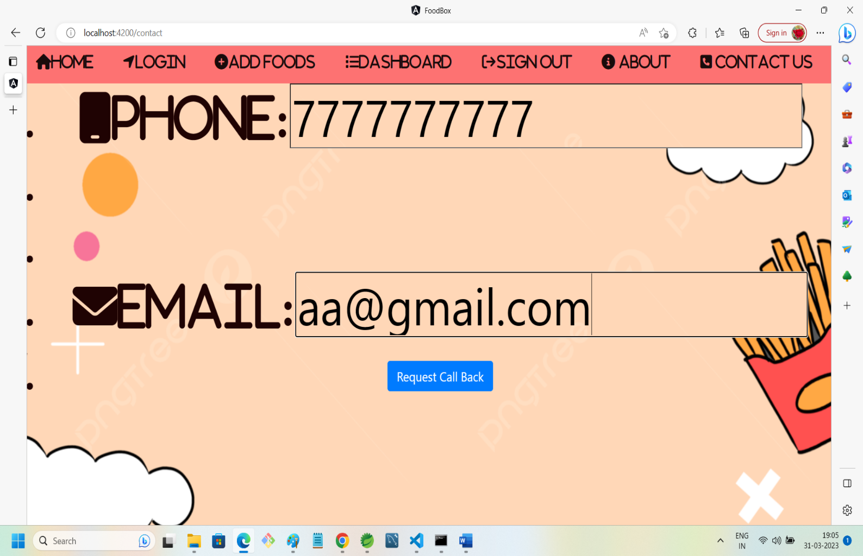

13. SIGN OUT ADMIN:

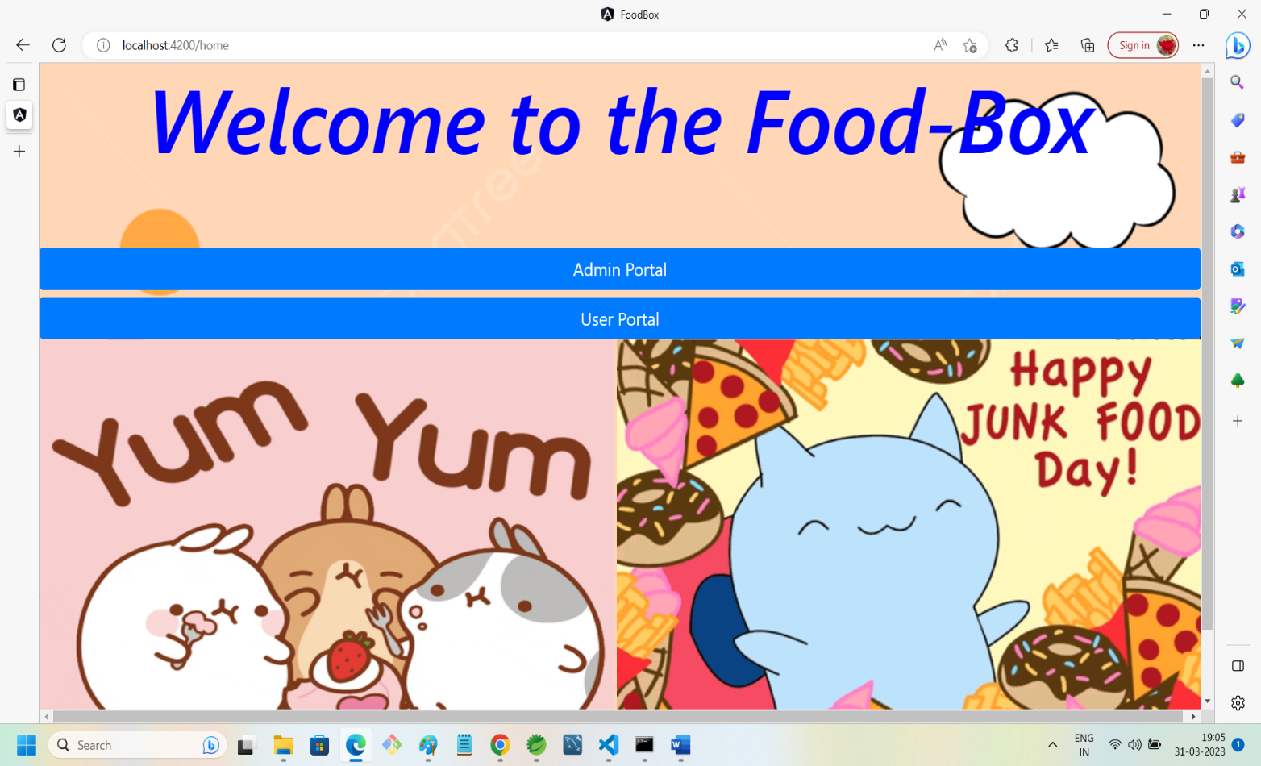

14. USER FRONT PAGE WITH BUY BUTTONS:

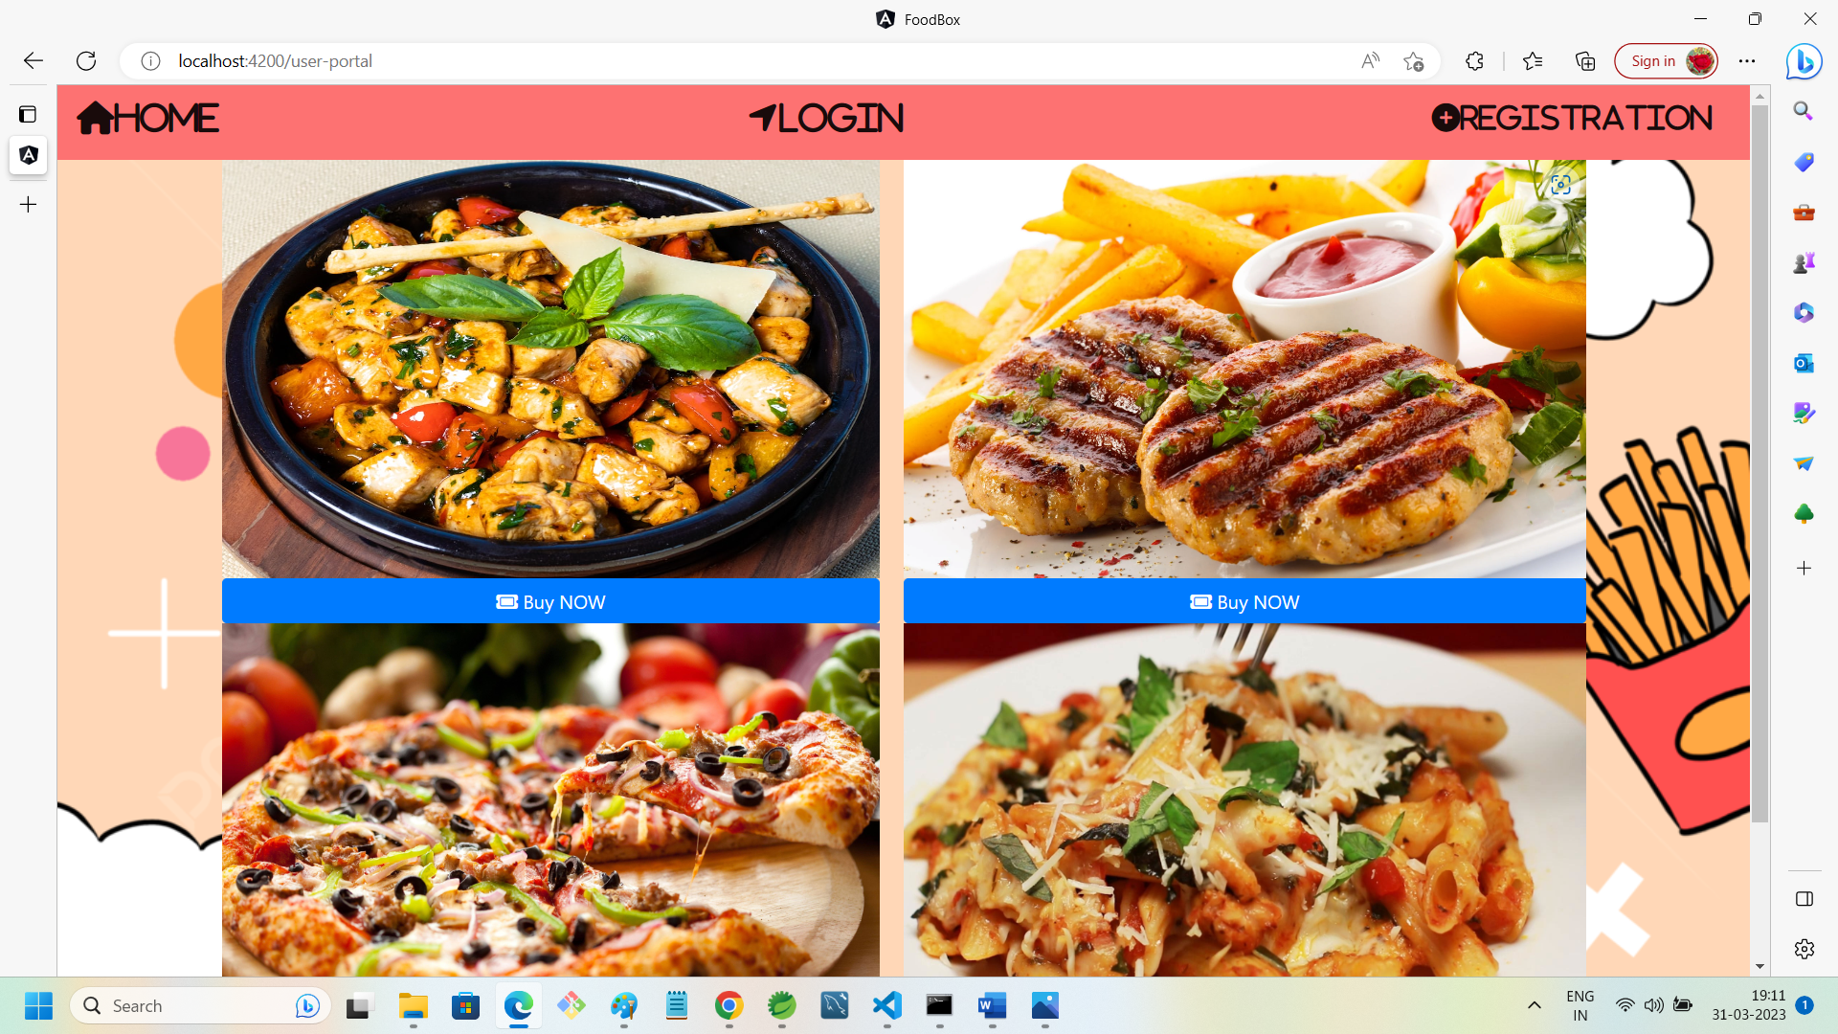

15. USER-PORTAL:

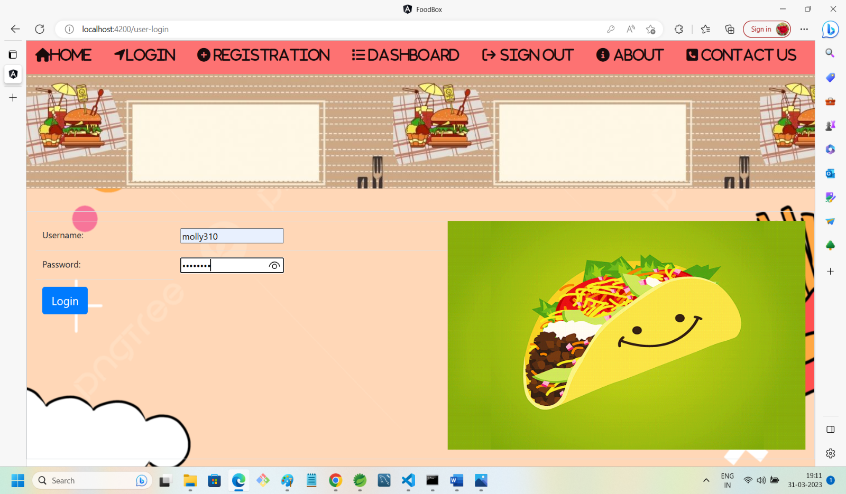

16. USER-DASHBOARD:

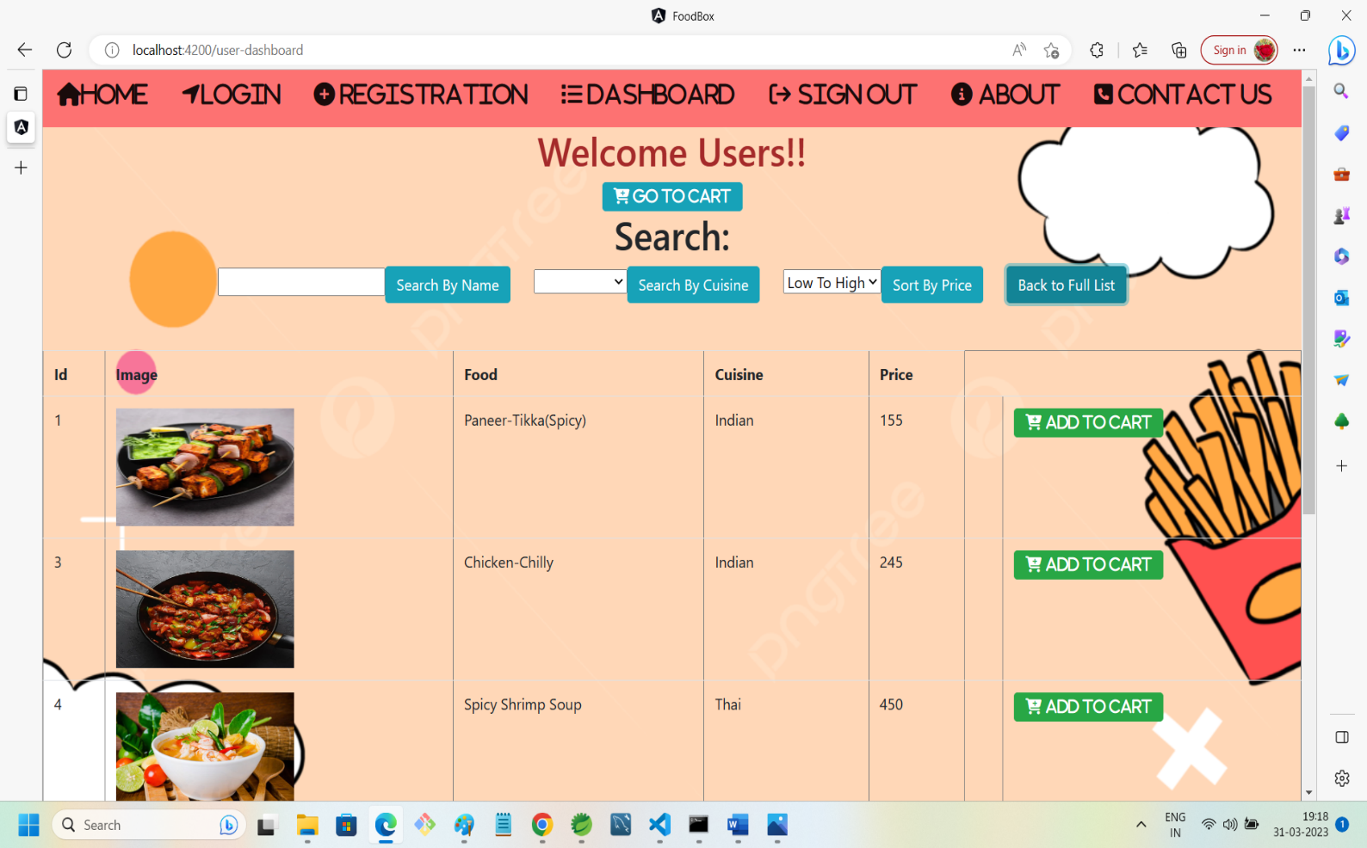

17. SEARCHING FOOD RESULT:

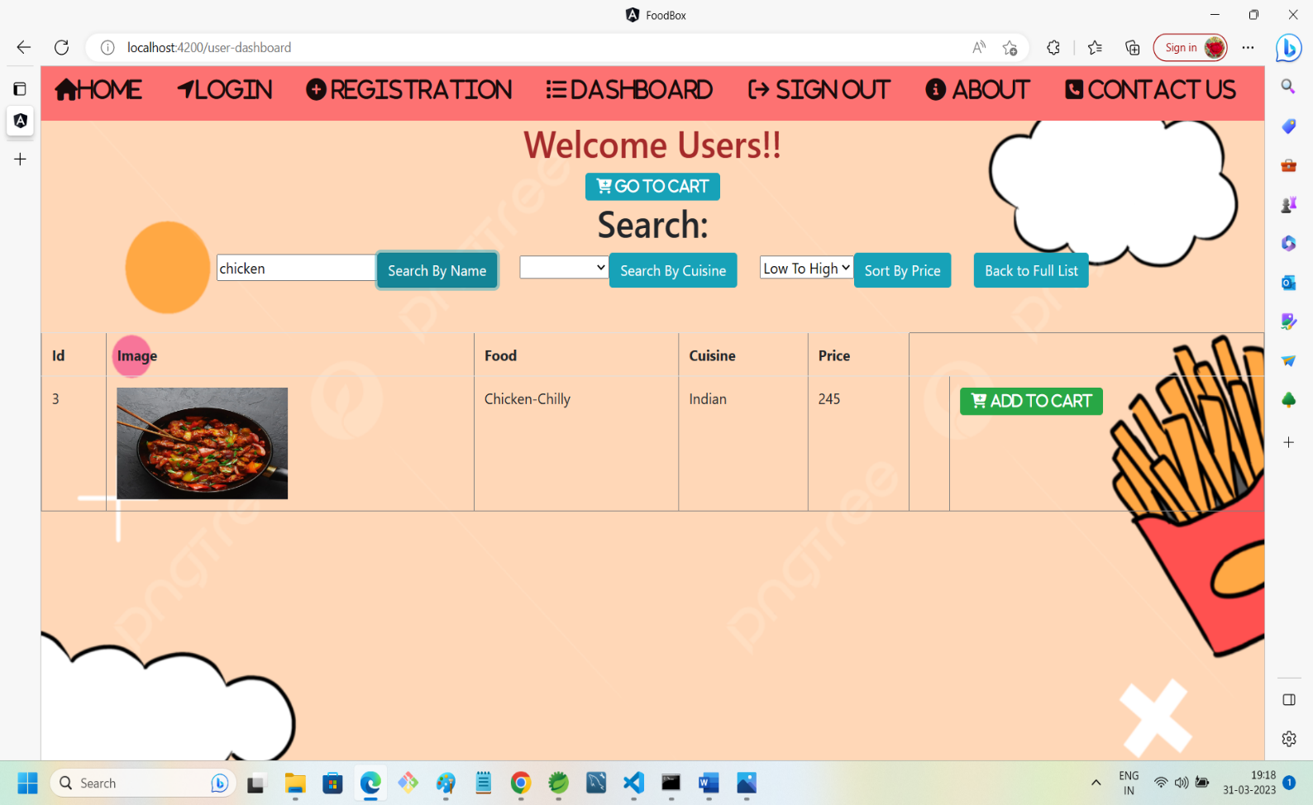

18. FILTERING FOOD WITH RESPECT TO CUISINE:

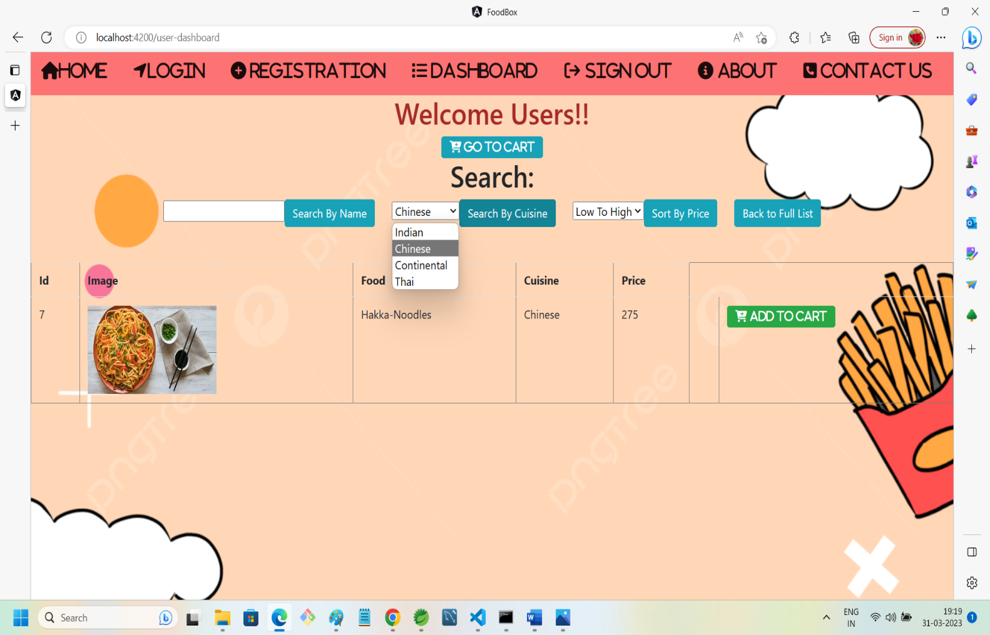

19. SORTING FOOD WITH RESPECT TO ITS PRICE:

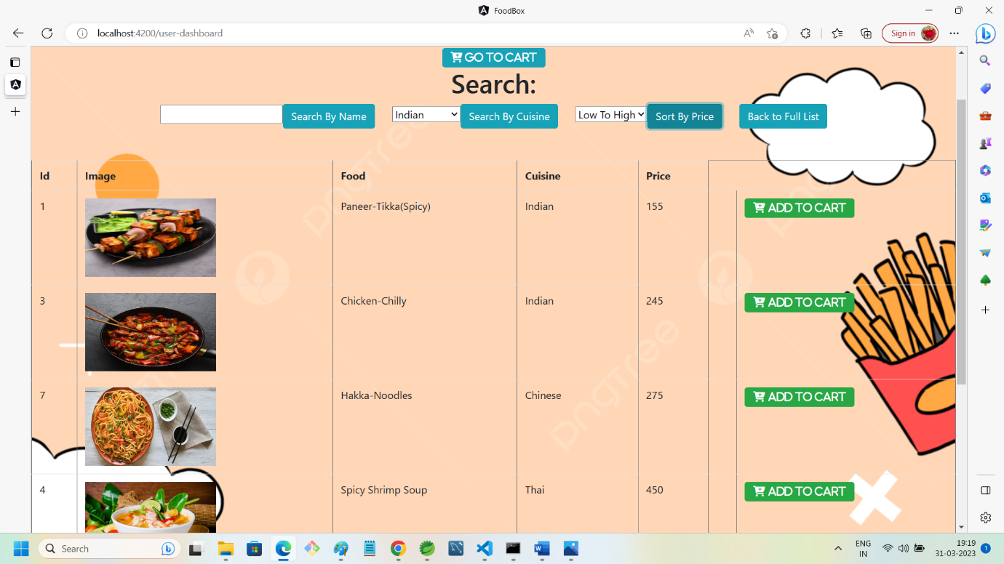

20. ADDING FOOD TO CART:

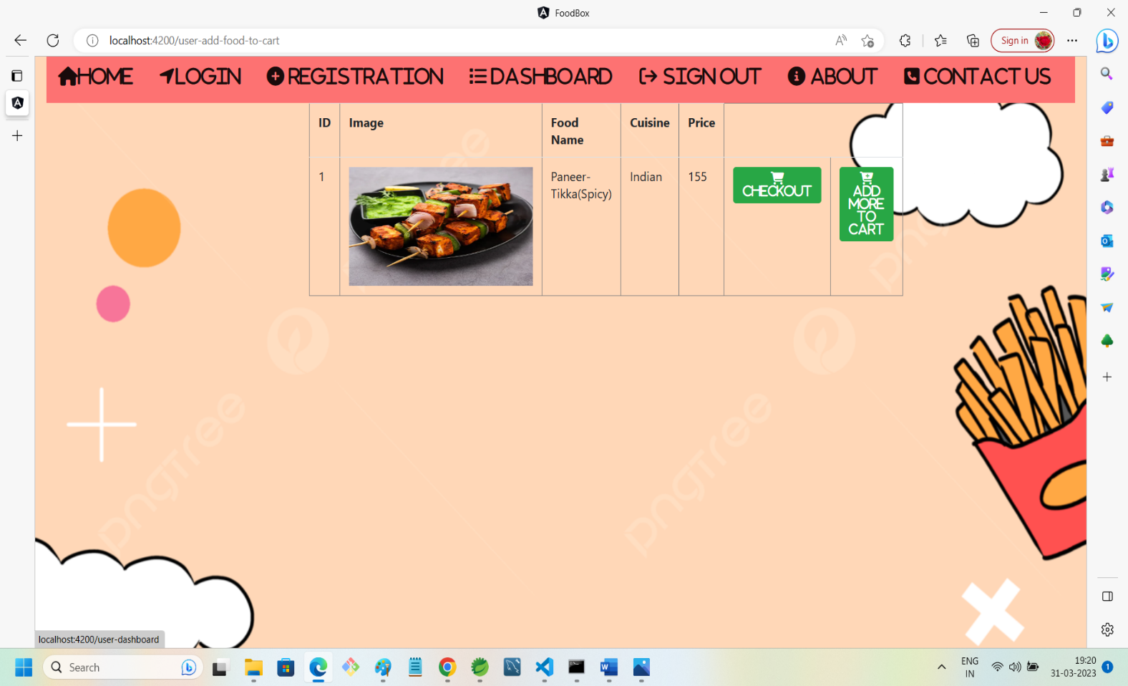

21. PROCEED TO CHECKOUT:

